**Ansh Ranjan  
ADF Case Study  
Exercise 4: Orchestrating Covid-19 Data Updates with ADF**

**TASK 1: Schedule the pipeline from Exercise 2 to run daily**

We already accomplish this task while building the said pipeline earlier

1. Click on Trigger > New/Edit > New > select type as Tumbling Runs > define start dates and reccurance time (going with 24 hrs)   
   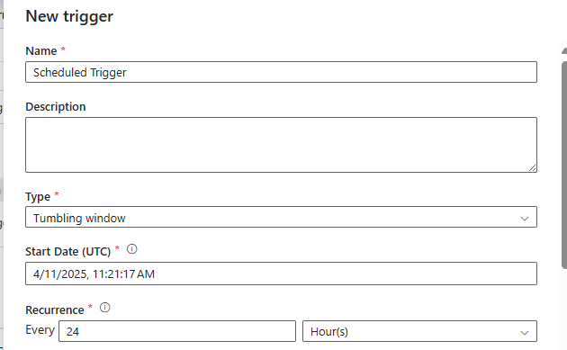
2. Publish your pipelines and Triggers.

**TASK 2: Implement a notification system for pipeline success/failure**

1. For notification system > Go to alerts and metrics > Declare new alert rule > In target criteria configure, when a pipeline is succeeded or failed you will get a notification. > You can choose the method of notification by configuring settings  
   A screenshot of a computer

   AI-generated content may be incorrect.